|  |  |
| --- | --- |
| **HEAD OF SCHOOL SEARCH**  **CATHOLIC MEMORIAL HIGH SCHOOL**  West Roxbury, MA  https://www.catholicmemorial.org/  Start Date: July 2026 |  |



**Mission Statement**

The value of a Catholic Memorial education is derived from a mindset of excellence in the classroom, on the field and through extra-curricular participation. The CM faculty teach and coach through methods attuned to how boys relate to information, creating in them ingenuity, adaptability and self-made success. CM forges leaders who are faith-filled, have a strong work ethic and who know right from wrong. Our graduates attend America's most respected universities and colleges becoming leaders across Boston in business, law, government, military and public safety. A CM education builds platforms on which our students can stand with confidence and look you in the eye while shaking your hand. CM is a brotherhood rooted in authentic diversity and fraternal trust and is a City of Boston school where character matters as much today as it has since its founding in 1957.

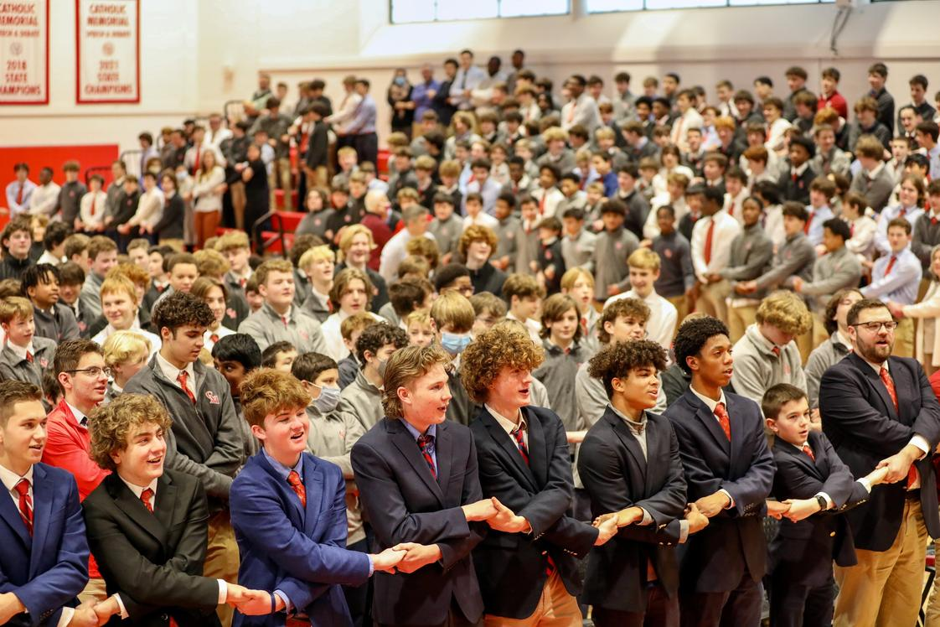

**Overview**

Catholic Memorial High School in West Roxbury, MA, has a rich history rooted in its mission to serve boys within the framework of Catholic values and in the spirit of the Christian Brothers. Since its founding, CM has cultivated a close-knit community characterized by genuine care, a strong sense of tradition, and an unwavering commitment to fostering character and academic excellence in every student. The school’s dedicated faculty and staff work collaboratively within a relatively autonomous environment, allowing for personalized teaching and a culture of trust that prioritizes student well-being, authenticity, and moral development.  
  
The school offers a dynamic learning environment that balances tradition with innovative approaches. Its programs emphasize academic rigor, sports, arts, and servant leadership, providing students with a broad and enriching experience. CM's physically revitalized campus, coupled with an academic infrastructure that is continually strengthening, underscores the school’s commitment to preparing boys for a successful future—whether in college, career, or community service. The community values authenticity and perseverance, and it nurtures a culture that meets boys where they are, encouraging growth through honest feedback, discipline, and Gospel principles.  
  
This is an exciting moment for Catholic Memorial, as it navigates key strategic priorities—such as attracting a broader demographic of students, enhancing its academic offerings, and ensuring sustainability amid shifting Catholic participation. The next Head of School will lead with a pragmatic, relational approach, able to sustain the school's positive momentum while thoughtfully embracing innovation and growth. A leader of authentic faith and entrepreneurial spirit, who also understands the unique identity of CM and can build on its strong foundation, will be essential in guiding the school through its next chapter of growth and stability.

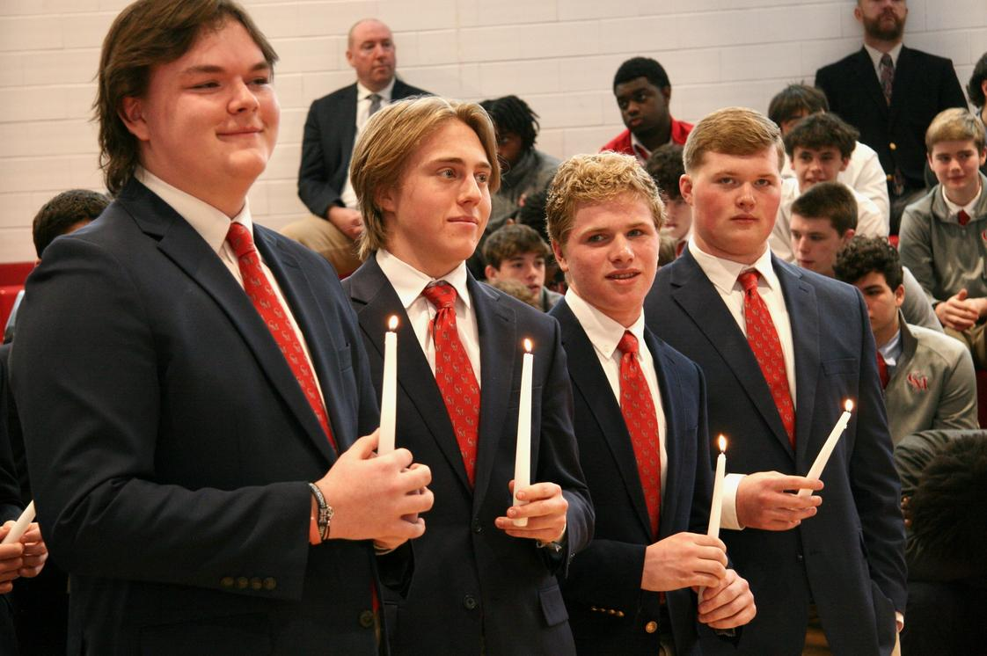

**Opportunities and Challenges**

Catholic Memorial High School stands at a pivotal moment, with a strong foundation rooted in its mission, dedicated faculty, and vibrant school community. The next Head of School will have the opportunity to build upon recent positive momentum—overseeing an ongoing campus overhaul, strengthening academic offerings, and enhancing community engagement. The school’s authentic culture of care, respect for tradition, and commitment to Gospel values are deeply valued and must be preserved as a core strength.  
  
This moment calls for a leader capable of sustaining Catholic Memorial’s unique identity and entrepreneurial spirit while addressing key challenges. The school faces demographic shifts with a decreasing Catholic student population and a need to innovate the student experience—particularly in expanding academic excellence, fostering diversity and inclusion, and investing in arts and extracurricular offerings. Maintaining the robustness of athletics amid resource considerations remains critical. While the school’s size offers intimacy and community, it also imposes limitations on growth and programming.  
  
The Head must navigate the financial sustainability of the school, with tuition-dependent funding requiring strategic stewardship and potential diversification. Strengthening fund-raising efforts, cultivating donor relationships, and reinforcing the school’s distinct value proposition will be vital.  
  
**Key opportunities and challenges include:**

• Sustaining and deepening the school's traditional values and caring culture amidst evolving demographic trends

• Leading strategic initiatives to attract a broader, more diverse student body and expand academic excellence

• Enhancing facilities and campus resources to support comprehensive academic, arts, and athletic programs

• Developing a long-term financial plan to improve sustainability and fund future growth

• Building on recent momentum to reinforce Catholic Memorial’s distinct identity within its competitive landscape

• Strengthening relationships with the Christian Brothers and navigating the school’s place within the larger Catholic community

• Serving as a relational, pragmatic leader who can foster collaboration, inspire faculty, and propel the school’s strategic vision

• Ensuring operational excellence and accountability without excessive bureaucracy

• Cultivating a dynamic, visible presence in the wider Boston community to elevate the school’s profile and outreach efforts

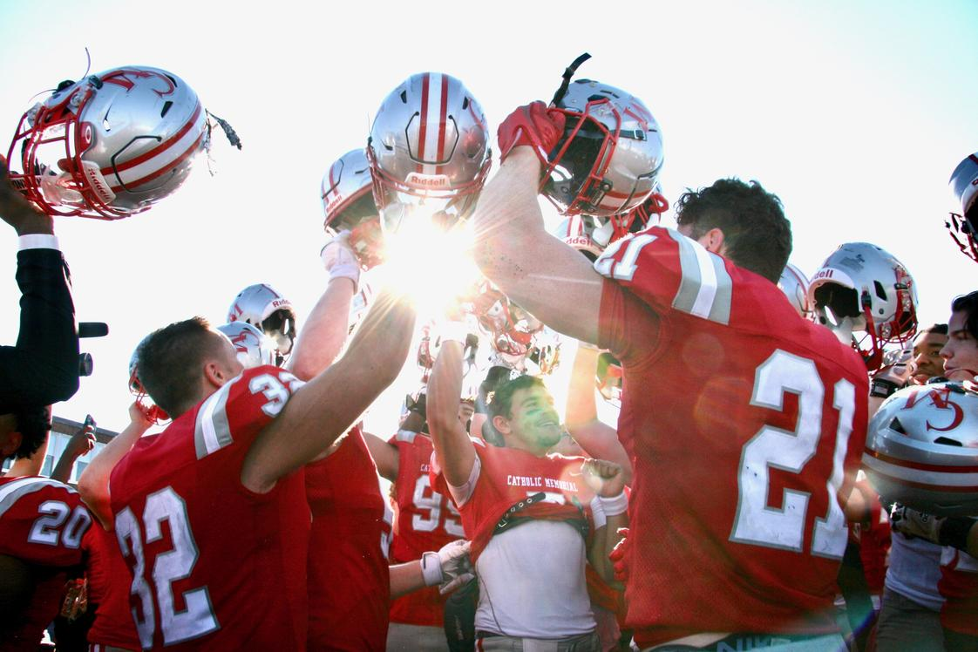

**Qualifications and Personal Attributes**

The ideal candidate for the Head of School at Catholic Memorial High School will be an authentic, approachable, and visionary leader deeply rooted in Catholic values and committed to sustaining and enhancing the school's mission. They will possess a strong sense of community, an entrepreneurial mindset, and the ability to build upon the school's positive momentum while thoughtfully navigating its unique challenges. With a focus on fostering relationships, inspiring staff, and engaging with families, this leader will represent a steady, yet innovative presence capable of guiding CM into its next chapter with humility, courage, and collaborative spirit.

Successful candidates will ideally demonstrate:

• Proven leadership experience within independent or Catholic secondary education environments, demonstrating strong relational skills

• Deep understanding of Catholic faith, doctrine, and mission to authentically embody and promote Gospel values

• Ability to develop strategic plans that balance tradition with innovation, fostering growth and sustainability

• Track record of building a collaborative, empowered faculty, staff, and leadership team in a small school setting

• Exceptional interpersonal and communication skills, with a relational and approachable leadership style

• Experience managing complex financial models, including tuition, fundraising, and resource allocation

• Strong capacity to lead change while maintaining core school values and community culture

• Comfort with risk-taking and entrepreneurial thinking to sustain and grow the school's distinctive identity

• Familiarity with Catholic education market dynamics, including enrollment challenges and demographic shifts

• Athletic and arts programming experience, with a focus on broadening offerings to meet diverse student needs

• Adeptness at fostering inclusive and equitable learning environments that serve a broad range of learners

• Ability to inspire trust and shared purpose among board members, families, students, and staff

• Demonstrated commitment to professional development, ensuring the school remains dynamic and innovative

• Personal qualities of humility, perseverance, courage, and a sense of humor, combined with a passionate dedication to Catholic education

• A strong entrepreneurial spirit balanced with pragmatic, down-to-earth leadership aligned with the school's ethos

**Learn More**

Click on the links below to learn more about Catholic Memorial High School.

|  |  |
| --- | --- |
| [School Website](https://www.catholicmemorial.org/) | [Town Information](https://www.boston.gov/neighborhood/west-roxbury) |
| [School History](https://www.catholicmemorial.net/vision-history/) |  |

**To Apply**

Interested and qualified candidates are invited to contact the consultants in confidence. Candidates will ultimately need to submit the following materials as separate PDF documents:

• A cover letter expressing their interest in this particular position;

• A current résumé;

• A statement of educational and leadership philosophy;

• A list of five professional references with name, relationship, phone number, and email address of each (references will not be contacted without the candidate's permission) to:

**Jim Shwartz**

Consultant

jim.shwartz@carneysandoe.com